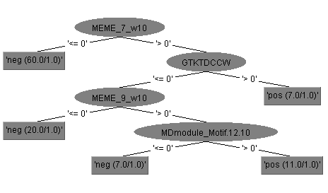

Figure 1B. The decision tree model to discriminate pollen-specific HRGP genes and non-pollen HRGP genes.